Name ____________________________________________
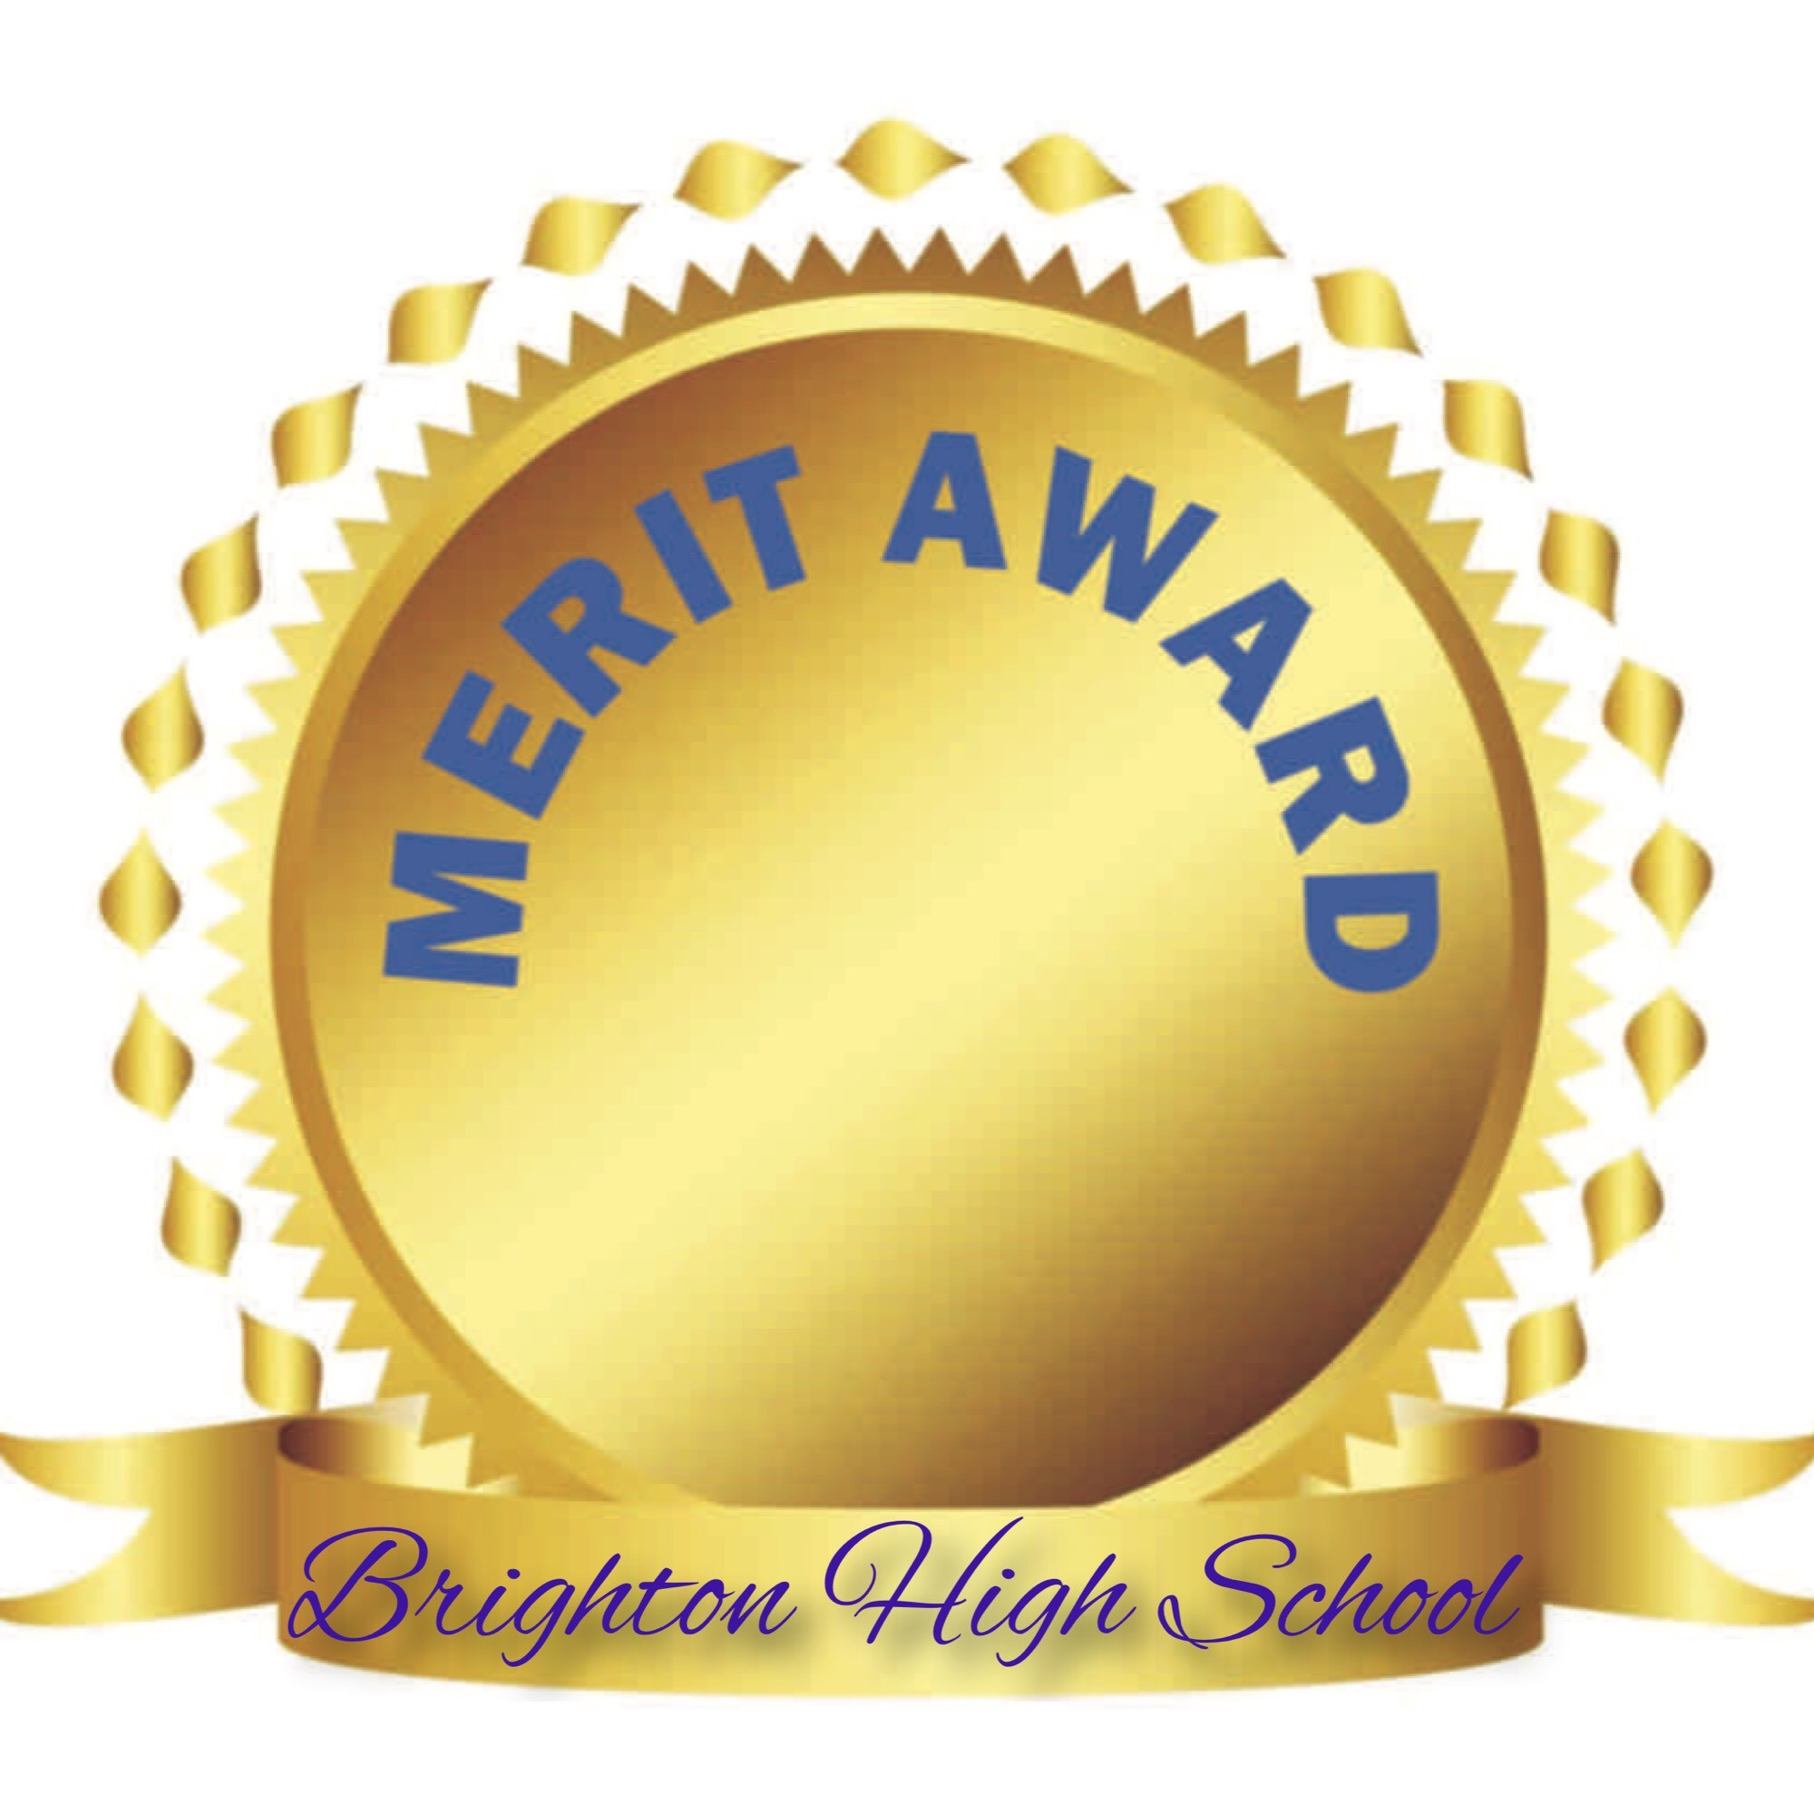

This application must be completed and submitted to Mrs. Shaw in the counseling center by March 29th, 3:00pm.
You MUST attach a copy of your transcript with your application.

DANCE
1. Participate in at least 2.0 credits (4 trimesters) of Dance Company, Dance 2, Dance 3 or Ballroom Dance.
LIST CLASSES:
1.
2.
3.
4.
2. Perform in at least 3 dance productions.
LIST PERFORMANCES: (name of show and year)
1.
2.
3.
3. Must have a minimum of 3.0 GPA in all dance classes.
____________________________________________
Advisor Signature required: Ms. Christensen

THEATRE
1. Complete 2.5 credits (5 trimesters) of Theatre grades 9-12.
LIST CLASSES:
1. 4.
2. 5.
3.
2. Compete in 3 competitions.
LIST COMPETITIONS:
1.
2.
3.
3. Participate in 3 Brighton Theatre Productions.
LIST PRODUCTIONS:
1.
2.
3.
4. Must have a minimum of 3.0 GPA in all theatre classes.

____________________________________________
Advisor Signature required: Ms. Curtis

INSTRUMENTAL/VOCAL MUSIC
Earning a letter in music 3 times during your career at Brighton will qualifies you for a Merit Cord. Please list the years you earned a letter:

OR
If you have not earned 3 letters in music, you can also earn a Merit Cord by fulfilling the following requirements:
- Complete 6 credits (12 trimesters) of music in grades 9-12.
PLEASE ATTACH A TRANSCRIPT
- Must have a minimum of 3.7 GPA in all music classes

OR
You can verify with Ms. Mortensen that you met the lettering requirements three years at Brighton or completed an alternate track to Instrumental Music Merit. You must schedule a meeting with Ms. Mortensen to verify this

____________________________________________
Advisor Signature required: Ms. Mortensen

2. Must have a minimum of 3.5 GPA in all music classes.
3. Complete 5 of any combination of the following:
- Participate in the school musical as a cast member or in the pit orchestra.
- Represent Brighton as a Music Sterling Scholar, runner-up or finalist.
- Participate in Brighton Concerto Night as a soloist.
- Qualify for and perform at State Solo & Ensemble.
- Take the AP Music Theory class and pass the AP Music Exam.
1.
2.
3.
4.
5.

____________________________________________
Advisor Signature required: Ms. Mortensen or Mr. Emrazian

VISUAL ARTS (Drawing, Painting, Ceramics, Jewelry, Photo, Commercial Art, Lettering and Calligraphy, Sculpture, AP Art 2D, AP Art 3D)
1. Complete 3.0 credits (6 trimesters) of Art classes in grades 9-12.
LIST CLASSES:
1. 4.
2. 5.
3. 6.
2. Work submitted to 2 Art Shows:
LIST SHOW:
1.
2.
3. Must have a minimum of 3.0 GPA in all art classes.

____________________________________________
Advisor Signature required: Mr. Chandler/Mr. Brun/Ms. Malan

No applications will be considered after March 29th, 3:00pm.

